**AWS Windows EC2 Instance Creation**

Step 1  
Go To Aws.Amazon.Com

Click On Sign In

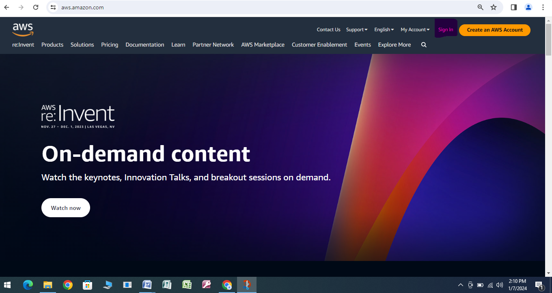

Step 2

Select Root User

Provide Root User Email Address

Click On Next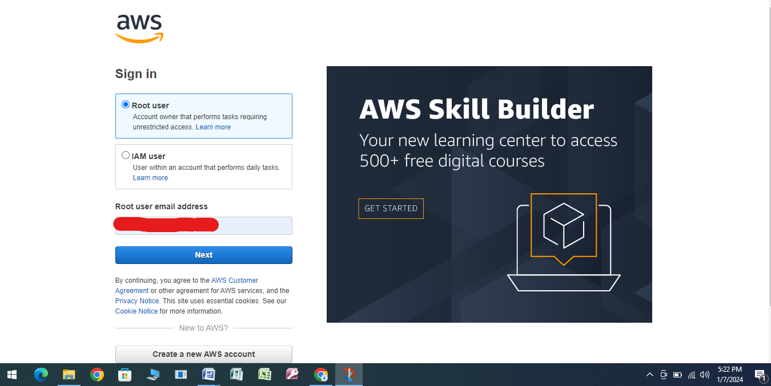

Step 3

Provide Password

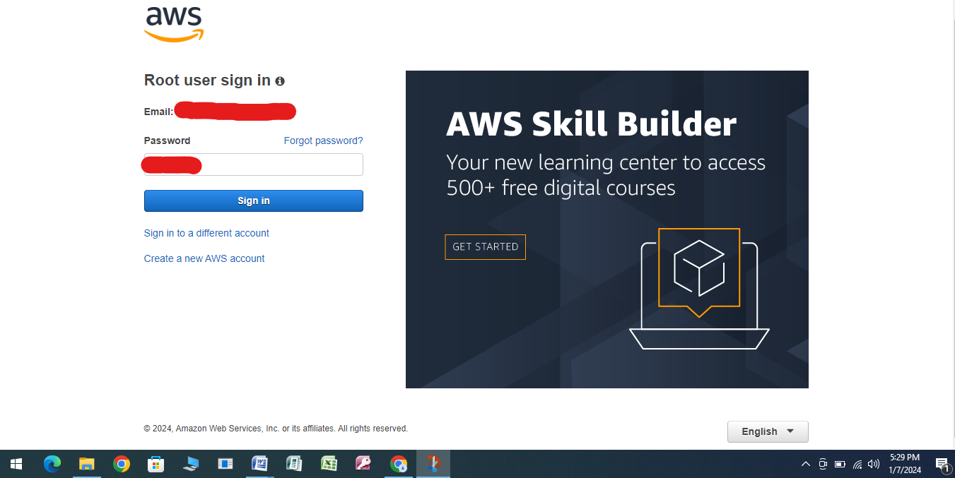

Step 4

Select The Nearest Region (Mumbai)

Search EC2 in Search Box

Select EC2 (Virtual Servers in the Cloud) From Drop Down Services

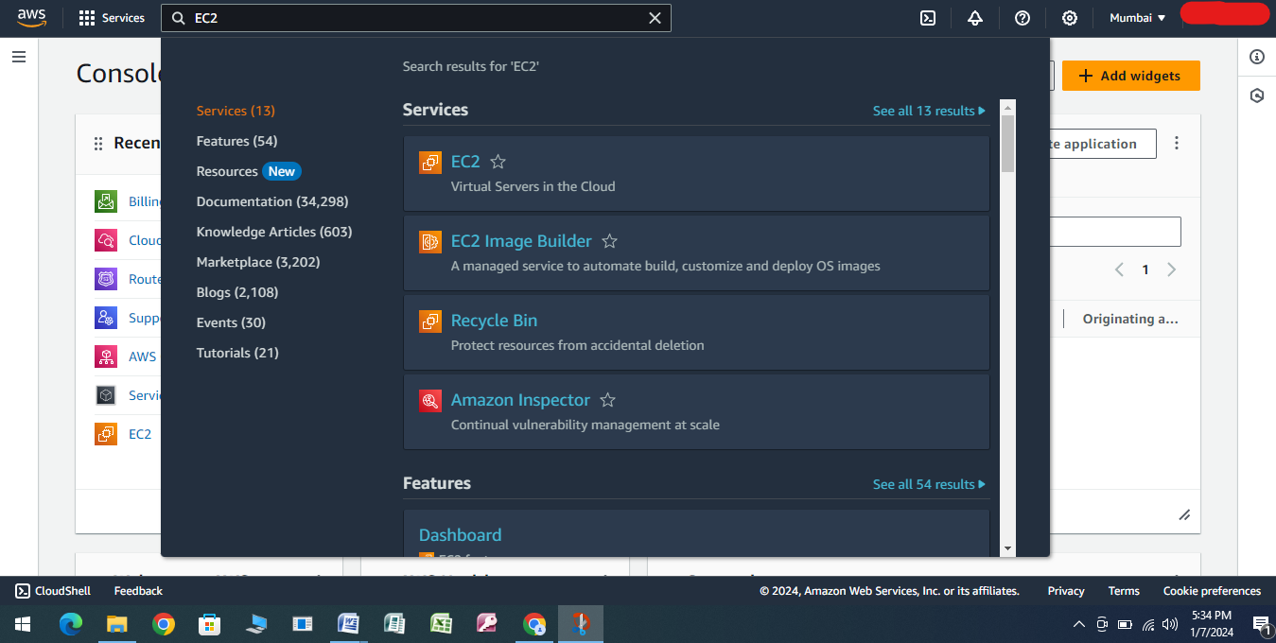

Step 5

You Would Be Landed in EC2 Dashboard

Click on Launch Instance

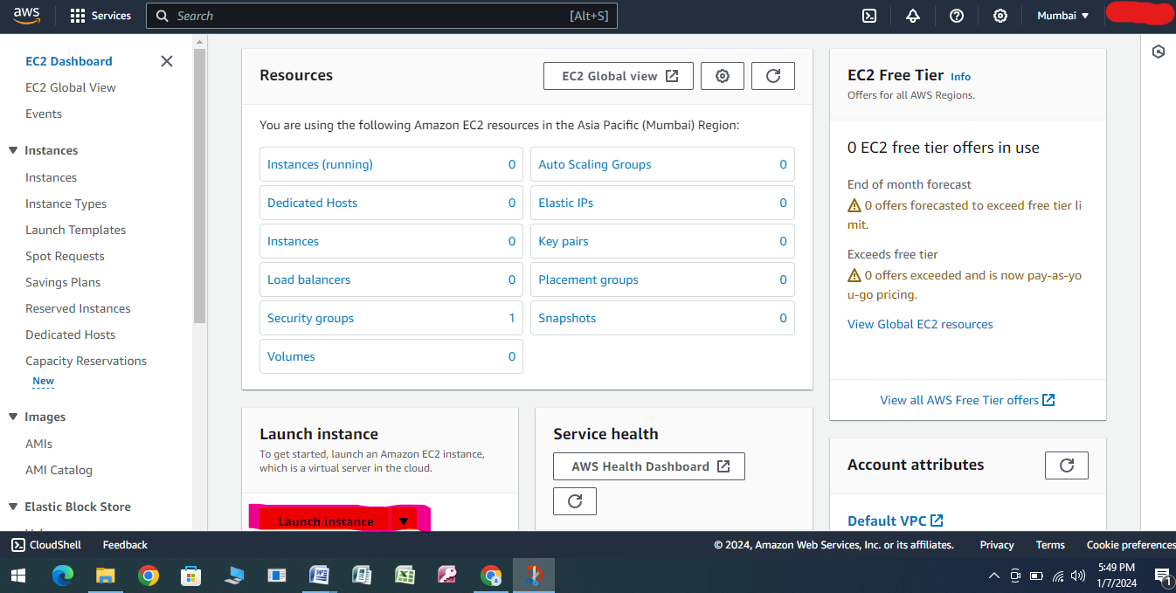

Step 6

Provide the Name Under Name and Tags

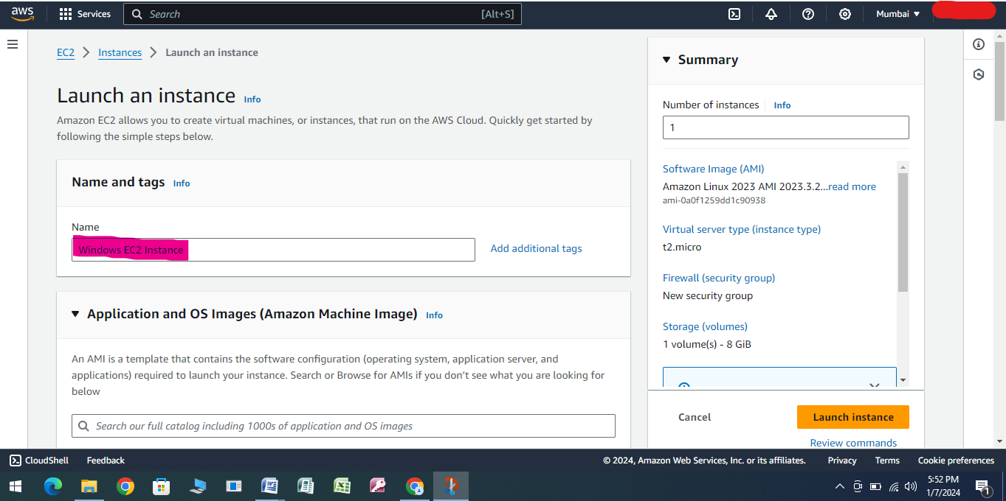

Step 7

Select Application and OS Images (Amazon Machine Image)

Click On Browse More AMIs Under Quick Start

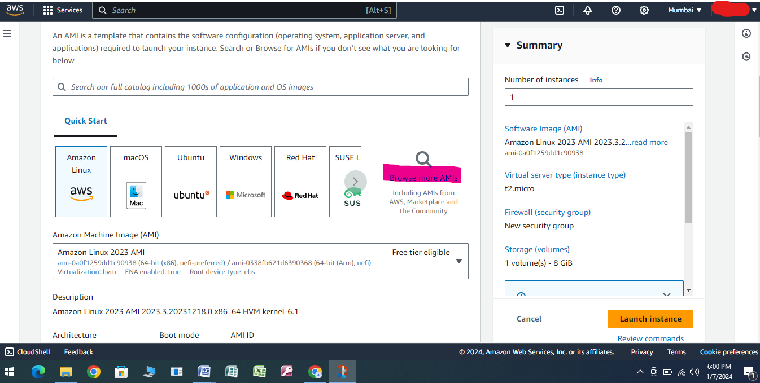

Step 8

Under Quick Start AMIs

Under Refine Filters Select Free Tier Only

Under OS Category Select All Windows

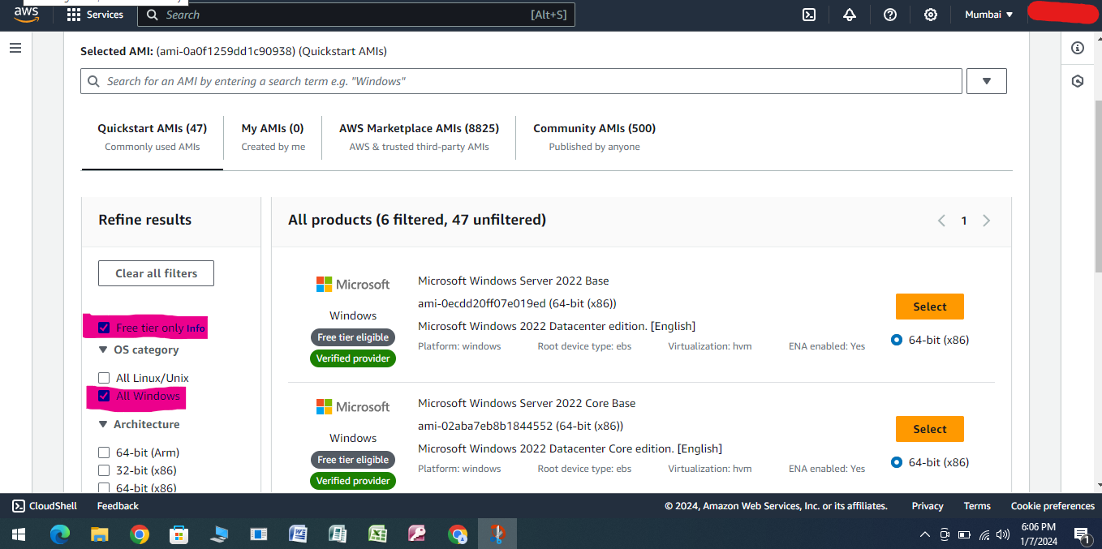

Step 9

Under Application And OS Images (Amazon Machine Image) Select Microsoft Windows Server 2019 Base considering its under free tier eligible

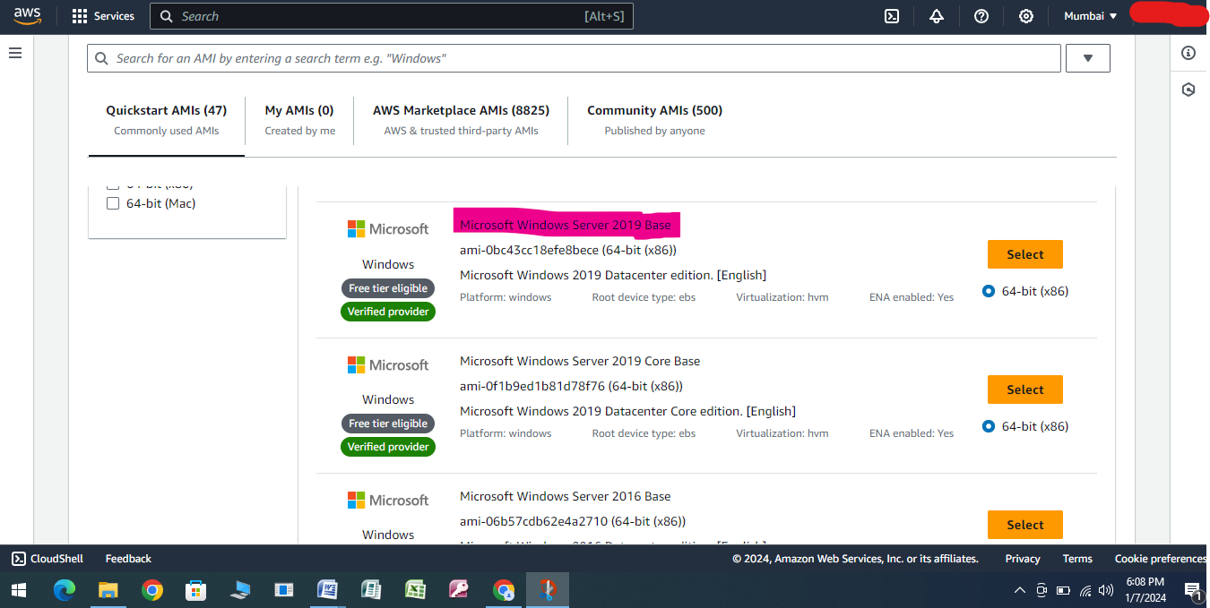

Step 10

Under Instance Type Select t2.micro considering its under free tier eligible

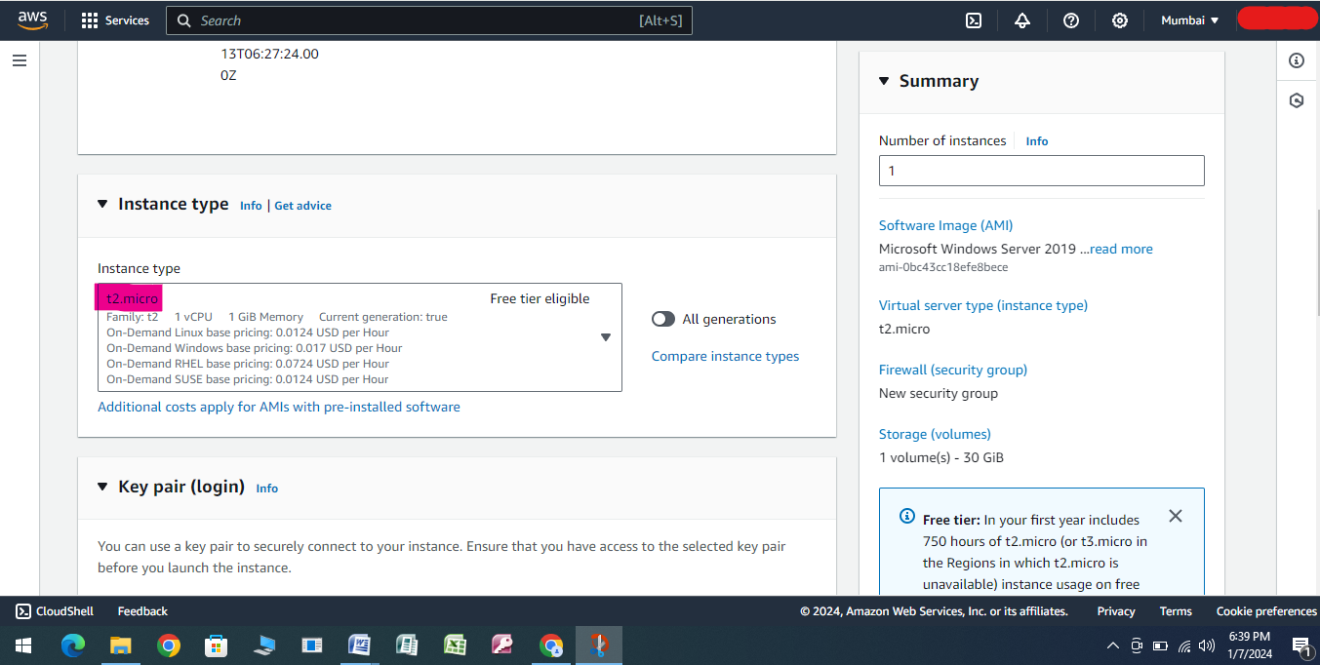

Step 11

Under Key Pair (login) select Create New Key Pair

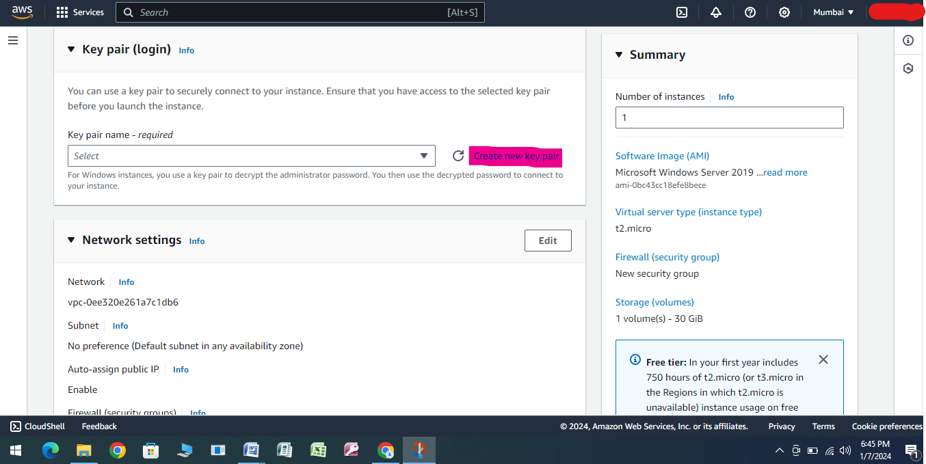

Step 12

Under Create Key Pair Provide Key Pair Name as “Windows EC2 Instance”

Under Create Key Pair Provide Key Pair Type as “RSA” (For Windows EC2 Instance RSA Would Be Preferred)

Under Create Key Pair Provide Private Key File Format as “.pem”

Click on Create Key Pair

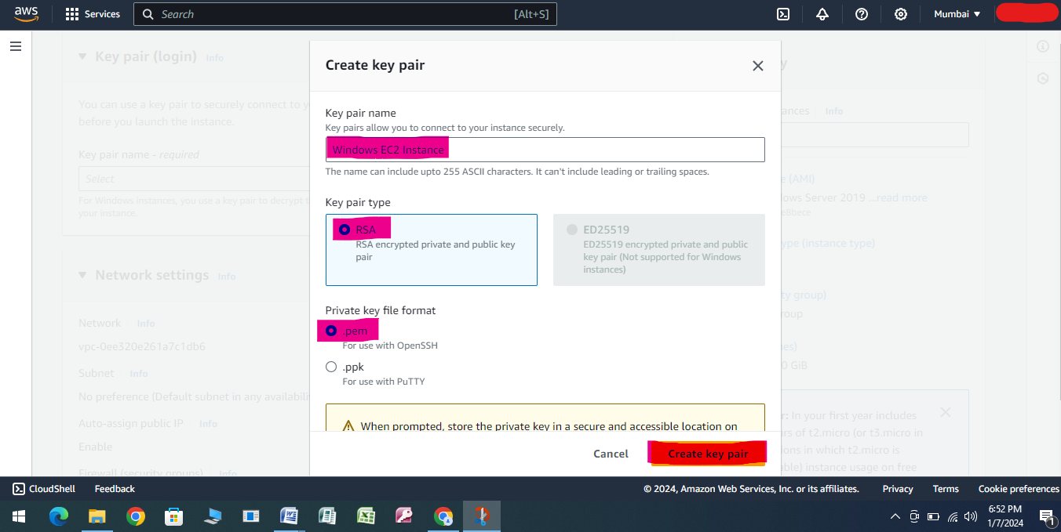

Step 13

A File Would Be Downloaded as Keep in the PC

Step 14

Under Network Settings Click On Edit

Under Network Settings VPC is Selected By Default

Under Network Settings Select the Subnet as Availability Zone ap-south-1a which is closer to the your region

Under Network Settings Select Auto-Assign Public-IP as Enable

Under Network Settings Select the Firewall (Security Groups) as Create Security Groups

Under Network Settings Select the Security Group Name as MSG

Under Network Settings Description is Selected By Default

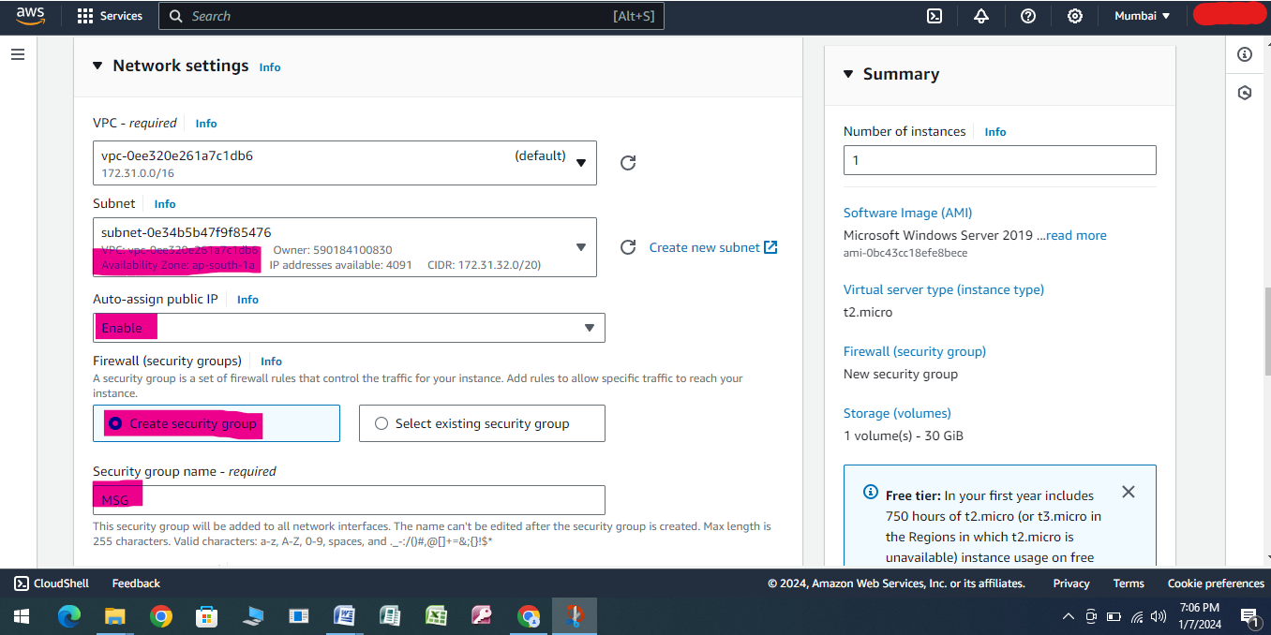

Step 15

Under Network Settings Select the Inbound Security Group Rules Type rdp, Protocol TCP and Port Range 3389 Source Type Anywhere when creating EC2 Instance.

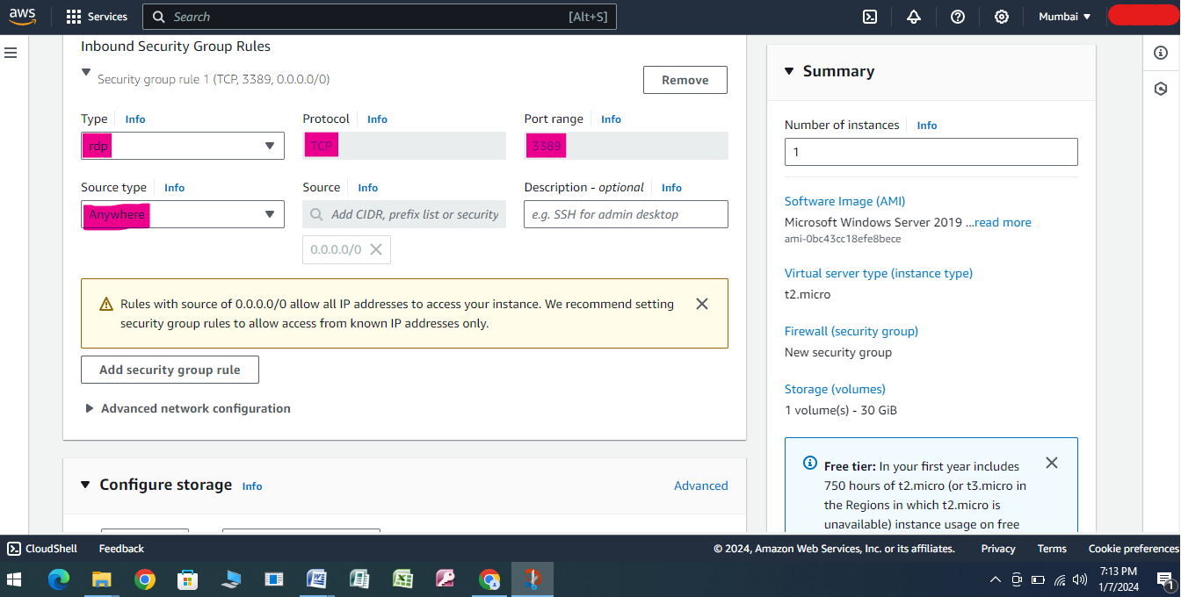

Step 16

Under Network Settings Select the Configuration Storage as 1*30 and Gib as gp2

Under Network Settings Select the File Systems as 0

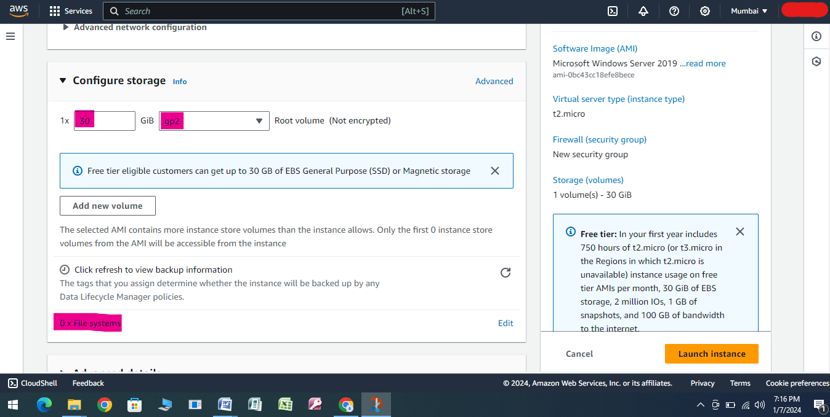

Step 17

Select the Number of Instances as 1

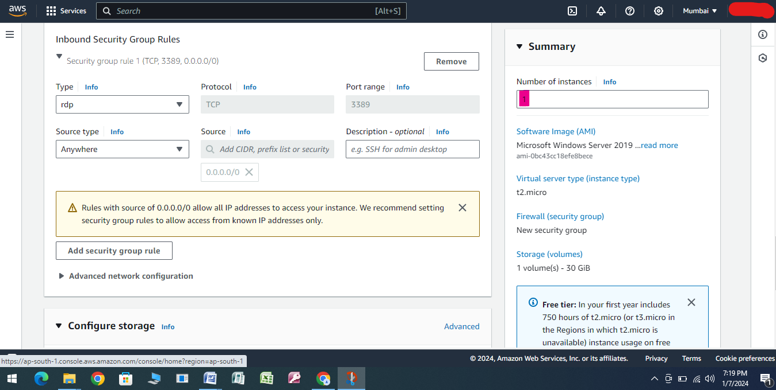

Step 18

Click on Launch Instance

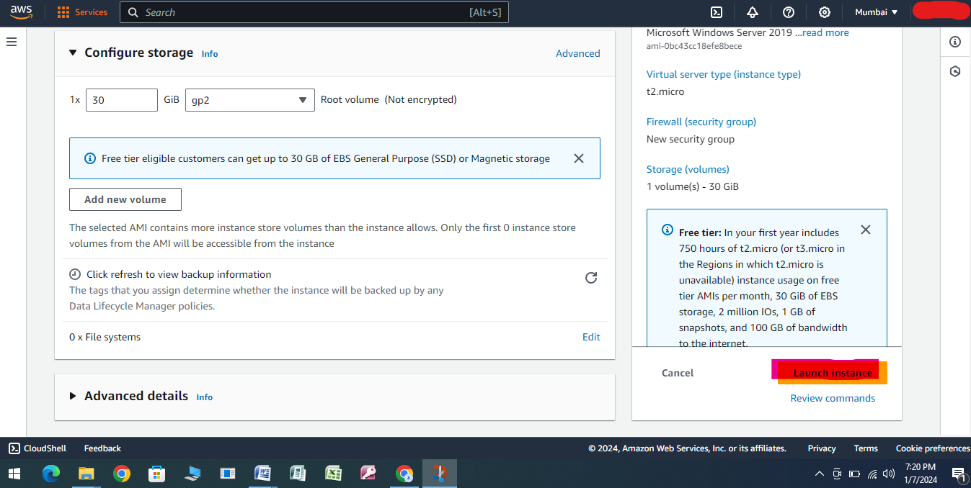

Step 19

Wait Until the Instance State is Running

Wait Until the Instance Status Check is 2/2

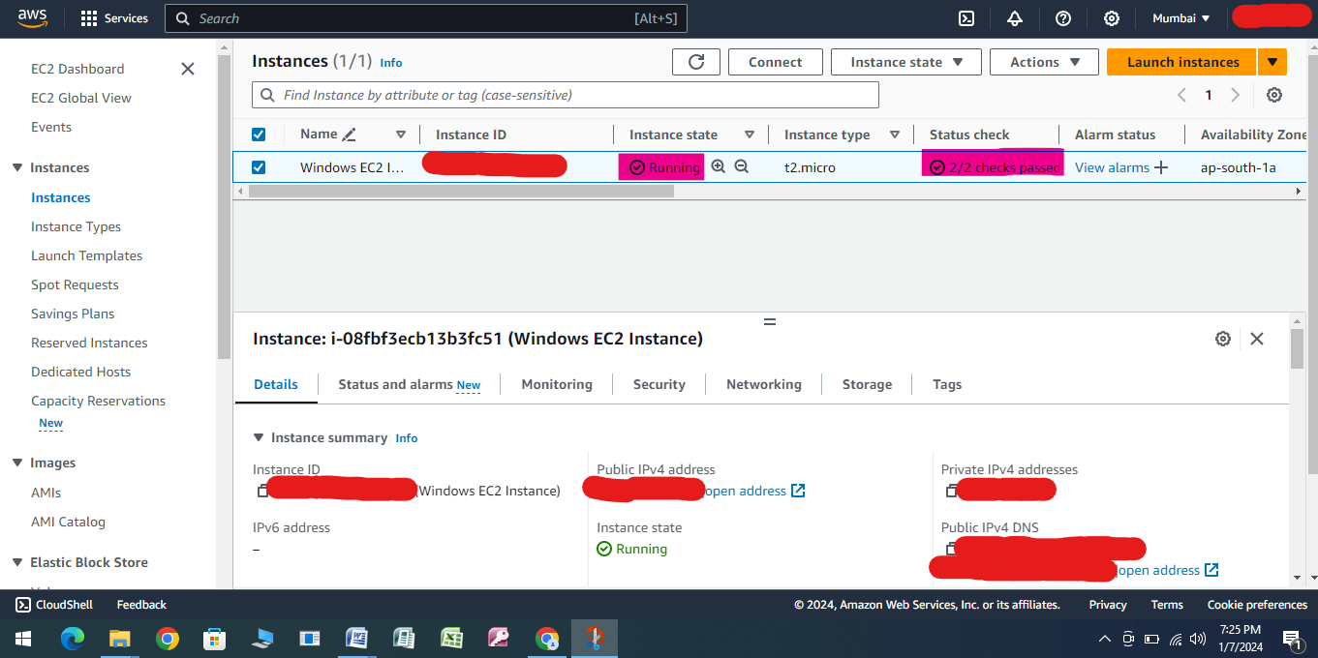

Step 20

Click on Connect after Selecting Instance you want to Launch

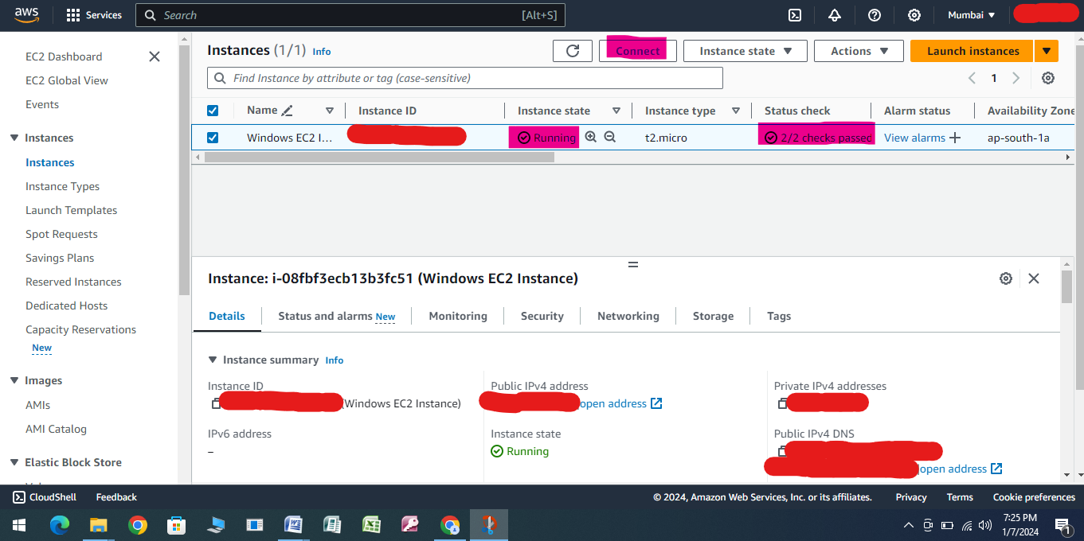

Step 21

Under RDP Client Select “Connect using RDP Client”

Click on Download Remote Desktop File

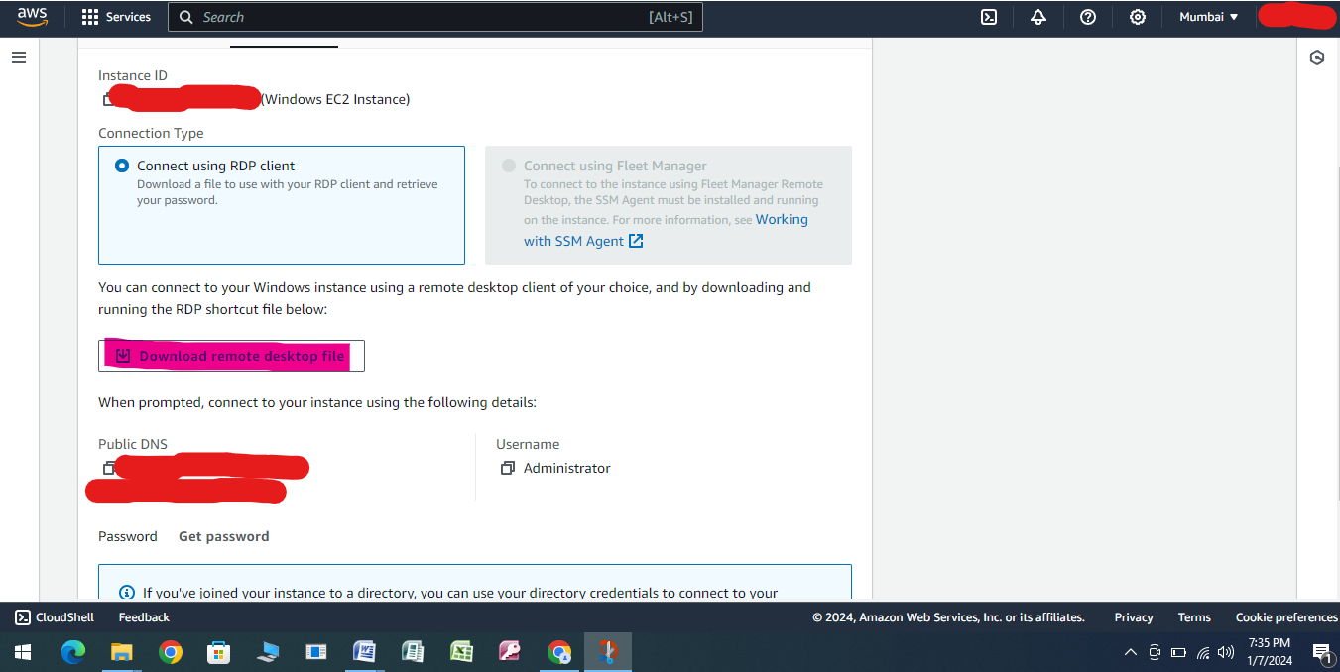

Step 22

Click on Connect

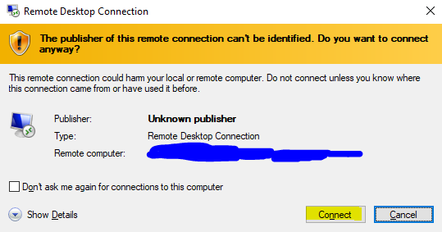

Step 23

Click on Get Password In AWS Console

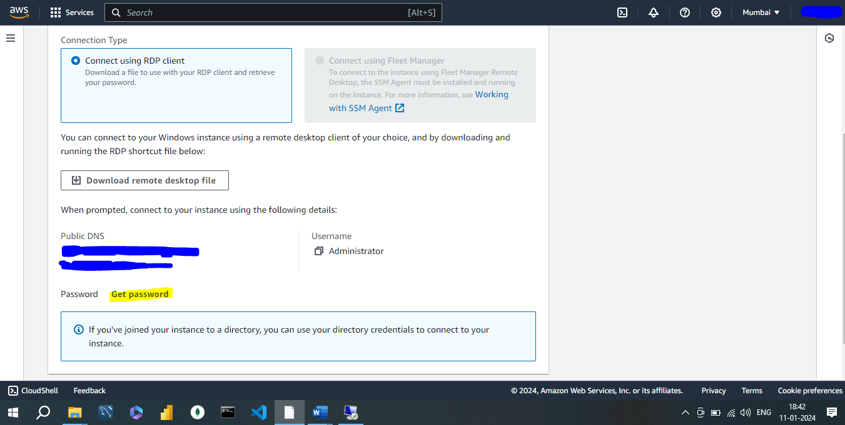

Step 24

Click on Upload Private Key

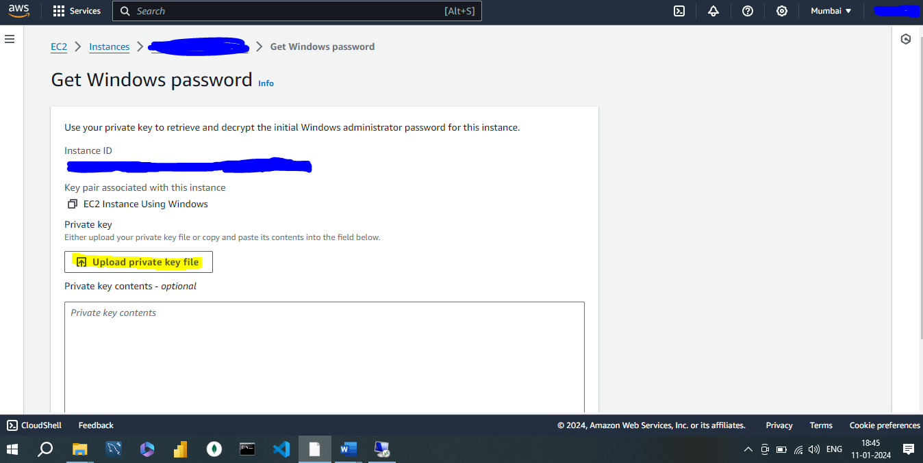

Step 25

Upload .pem file and click on Decrypt Password

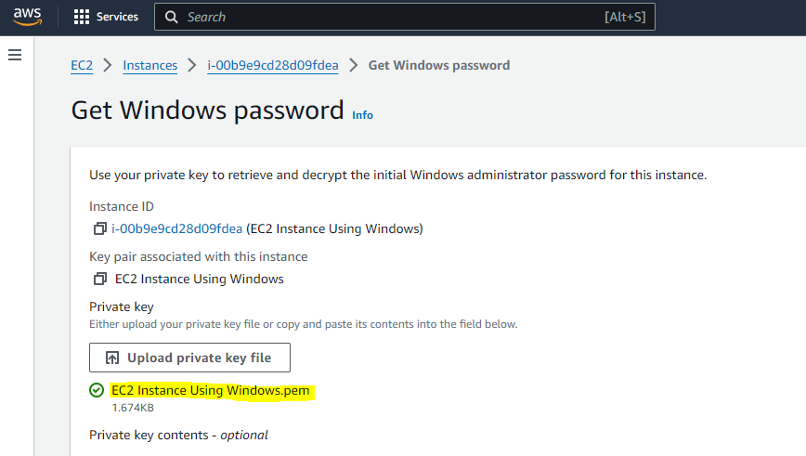

Step 26

Copy the Decrypted Password from AWS Console and paste in windows RDP and would be login to windows EC2 Instance

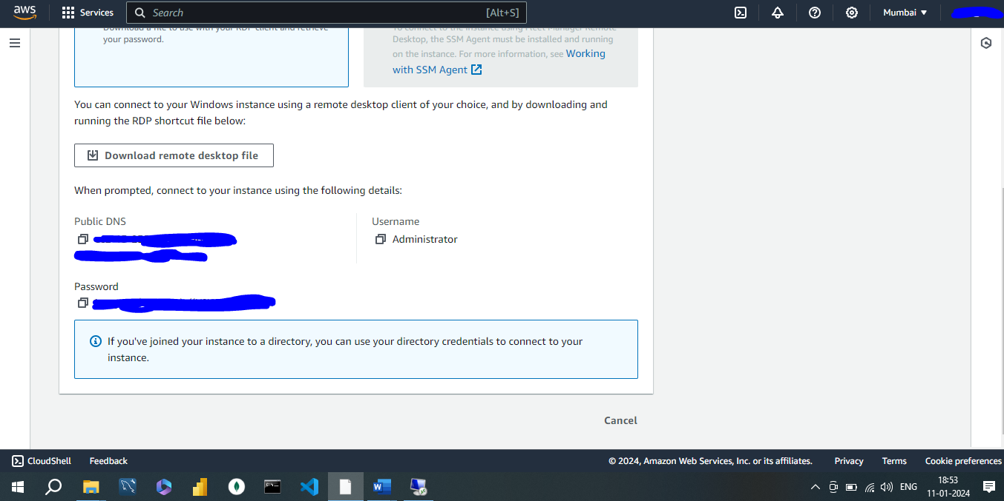

Step 27

After Using Windows EC2 Instance Stop and Terminate the Instance

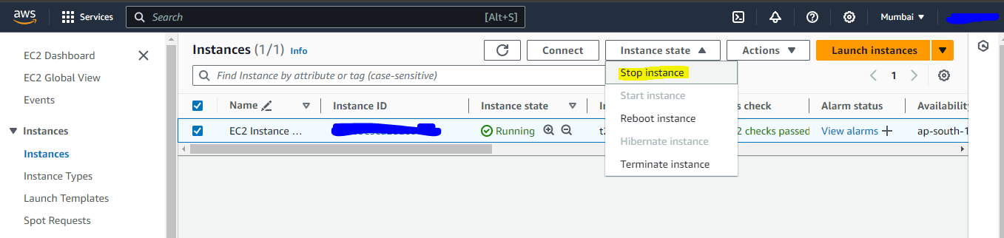

Step 28

After Using Windows EC2 Instance Terminate the Instance

